MEDICINE RECOMMENDATION SYSTEM

NAMES: SYEDA ALAINA BIT-23F-040

MARIA KHUZEMA BIT-23F-031

FATIMA MAJEED BIT-23F-046

SUBJECT: ARTIFICIAL INTELLIGENCE.

MEDICINE RECOMMENDATION SYSTEM

CODE:

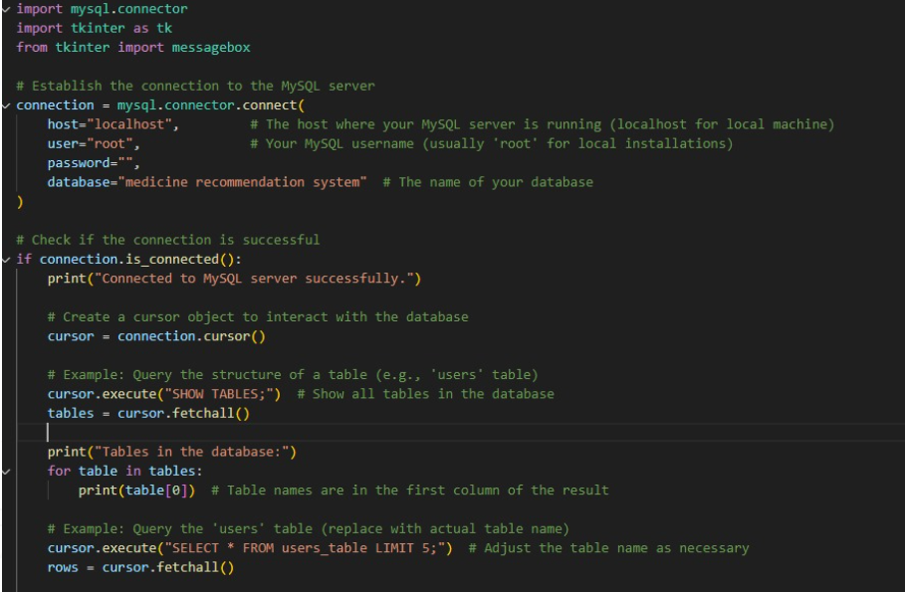

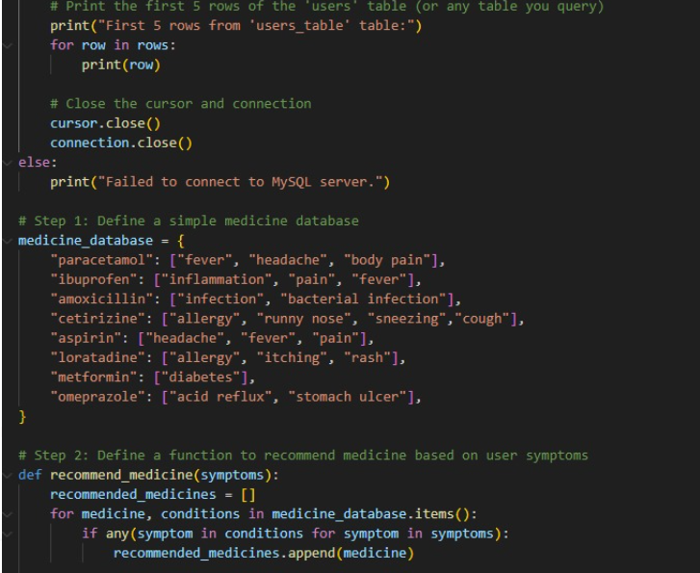

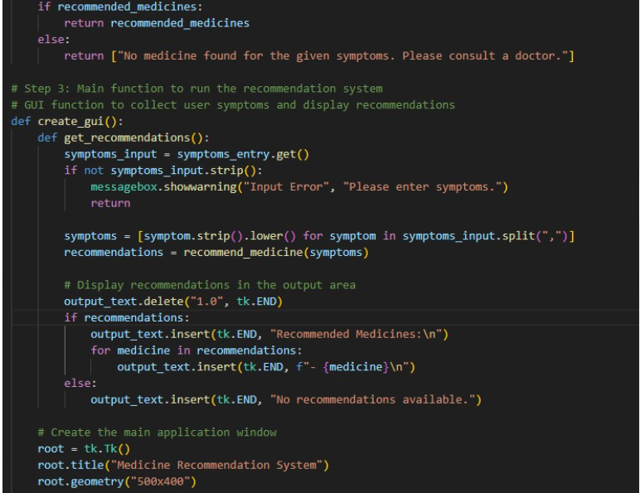

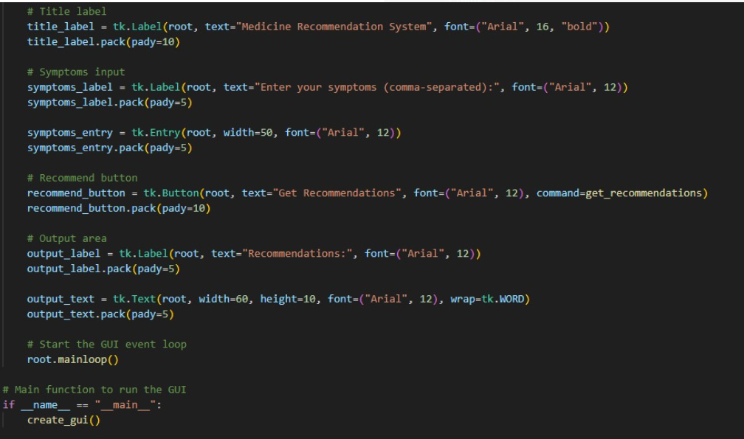

OUTPUT:

